**Table of Contents**

### Page No.

### Chapter 1. Introduction

1. Introduction to the System 4
2. Problem Definition 4
3. Aim 4
4. Objective 4
5. Goal 5
6. Need of System 5

### Chapter 2. Hardware and Software requirement

1. Introduction 7
2. System environment 7
3. Software requirement 8
4. Hardware requirements 8

### Chapter 3. System Analysis

1. Purpose 9
2. Project Scope 9
3. Existing System 9
4. Proposed System 9
5. System Description 10

### [Chapter 4.Implementation issues](#chap 8)

1. Python 11
2. HTML 13
3. Cascading style sheet(CSS) 16
4. MYSQL

**Chapter 5. System Design**

1. Introduction 21
2. Conceptual Design 22
3. ER-Diagram 23
4. Logical Design 23
5. Physical Design 24
6. Data Flow Diagram of **“Online Grocery Shop”**

24

### [Chapter 6.User Screens](#chap 8) 25-32

### [Chapter 7.Coding](#chap 8) 33-113

[**Chapter 8. Conclusion**](#chap 9)

1. Features of “Online **Grocery** Shop” 114
2. Benefits Accrued from “Online **Grocery** Shop ” 114
3. Limitations of “Online **Grocery** Shop” 115

Bibliography

**CHAPTER** # **1**

**Introduction**

*Contents:*

* Introduction
* Problem Definition
* Aim
* Objective
* Goal
* Need of System

**Introduction to the System:**

The “Online Grocery Shop Project” has been developed to override the problems prevailing in the practicing manual system. This software is supported to eliminate and in some cases reduce the hardships faced by this existing system. Moreover this system is designed for the particular need of the company to carry out operations in a smooth and effective manner.

This application is reduced as much as possible to avoid errors while entering the data. It also provides error message while entering invalid data. No formal knowledge is needed for the user to use this system. Thus by this all it proves it is user-friendly . Online Grocery Shop Management System, as described above, can lead to error free , secure , reliable and fast management system. It can assist the user to concentrate on their other activities rather to concentrate on the record keeping. Thus it will help organization in better utilization of resources.

Every food organization, whether big or small, has challenges to overcome and managing the information of groceries, customer, groceries stock, sells.

**Problem Definition:**

Managing your online grocery shopping system may seem tricky, but this is part of Customer service system (application support direct contact with customer)

.

**Aim:**

# “To Manage Online Grocery Shopping”.

**Objective:**

This software helps customer to find different products according category, price, and subcategory. It is designed such a way that one can view all the updates of the products from any place through online. The software will help in easy maintaining and updating products in the website for the administrator. Also quick and easy comparison of different products for the customers.

**Goal:**

The project is basically targeted at those people who would like online shopping and have an Internet access.

Finally buyers curious in comparing the prices for various products for according our budget.

To make a database that is consistent, reliable and secure.

To provide correct, complete, ongoing information.

To develop a well-organized information storage system.

To make good documentation so as to facilitate possible future enhancements.

**Need of the System:**

There is always a need of a system that will perform to purchasing grocery products online according to customer requirement.

This system will reduce the manual operation required to maintain all the records of booking information. And also generates the various reports for analysis. Main concept of the project is to enter transaction reports and to maintain customer records. Hence this software can be used in any grocery shop to maintain their record easily.

**CHAPTER** # **2**

**Hardware and Software Requirements**

*Contents:*

##### Introduction

* System environment
* Software requirement
* Hardware requirements

**Introduction:**

In this chapter we mentioned the software and hardware requirements, which are necessary for successfully running this system. The major element in building systems is selecting compatible hardware and software. The system analyst has to determine what software package is best for the **“Online Grocery Shop System”** and, where software is not an issue, the kind of hardware and peripherals needed for the final conversion.

**System Environment:**

After analysis, some resources are required to convert the abstract system into the real one. All the resources, which accomplish a robust

The hardware and software selection begins with requirement analysis, followed by a request for proposal and vendor evaluation.

Software and real system are identified. According to the provided functional specification all the technologies and its capacities are identified. Basic functions and procedures and methodologies are prepared to implement. Some of the Basic requirements such as hardware and software are described as follows: -

**Hardware and Software Specification**

**Software Requirements:**

* Technology: Python Django
* IDE : Pycharm/Atom
* Client Side Technologies: HTML, CSS, JavaScript , Bootstrap
* Server Side Technologies: Python
* Data Base Server: Sqlite
* Operating System: Microsoft Windows/Linux

**Hardware Requirements:**

* Processor: Pentium-III (or) Higher
* Ram: 64MB (or) Higher
* Hard disk: 80GB (or) Higher

**CHAPTER** # **3**

**System Analysis**

*Contents:*

##### Purpose

* Project Scope
* Existing System
* Proposed System
* System Overview

### Purpose:

To manage the online shopping of grocery products. It helps to customer to search and buy medicines from anywhere. Also make payment on delivery for it. It helps to people to book desired products at their prefer time.

**Project Scope:**

The project has a wide scope, as it is not intended to a particular organization. This project is going to develop generic software, which can be applied by any businesses organization. More over it provides facility to its customer. Also the software is going to provide a huge amount of summary data.

**Proposed System:**

The online grocery shop system is available in the market that can serve customers to book/purchase grocery products online.

**System Overview:**

The key features required in the system are as follows:

* **Login:** This module has a drop down list box from where we have to select

**ADMIN or USER**. The **ADMIN** has all the rights in the software including updating the status of his site. The other fields in login **are** username and password. If the username and password are correct then it is directed to next page.

* **New user:** This module is for the users who do not have their account. Here user is allowed to create an account to login. The account creation is done by filling the registration form with user details such as name, phone, email etc.
* **Product:** This module has information regarding the medicines such as its name, category, subcategory , image , price information, its features etc.The **ADMIN** has the authority to Add, Delete, Update etc. The **USER** can only view the products available in the stock etc.
* **Search:** This module helps the customer to ease his search based on his budget or interest. The search can be done on different categories and subcategories like category , subcategory , name, price etc

**CHAPTER** # **4**

**Implementation issues**

**Python**

Python is a widely used general-purpose, high level programming language. It was initially designed by Guido van Rossum in 1991 and developed by Python Software Foundation. It was mainly developed for emphasis on code readability, and its syntax allows programmers to express concepts in fewer lines of code.

Python is a programming language that lets you work quickly and integrate systems more efficiently.

Python is dynamically typed and garbage-collected. It supports multiple programming paradigms, including procedural, object-oriented, and functional programming. Python is often described as a "batteries included" language due to its comprehensive standard library.

**HTML**

HTML (Hypertext Markup Language) is the set of markup symbols or codes inserted in a file intended for display on a World Wide Web browser page. The markup tells the Web browser how to display a Web page's words and images for the user. Each individual markup code is referred to as an element (but many people also refer to it as a tag). Some elements come in pairs that indicate when some display effect is to begin and when it is to end.

**CASCADING STYLE SHEET (CSS)**

Cascading Style Sheets (CSS) are a collection of rules we use to define and modify web pages. CSS are similar to styles in Word. CSS allow Web designers to have much more control over their pages look and layout. For instance, you could create a style that defines the body text to be Verdana, 10 point. Later on, you may easily change the body text to Times New Roman, 12 point by just changing the rule in the CSS. Instead of having to change the font on each page of your website, all you need to do is redefine the style on the style sheet, and it will instantly change on all of the pages that the style sheet has been applied to. With HTML styles, the font change would be applied to each instance of that font and have to be changed in each spot.

CSS can control the placement of text and objects on your pages as well as the look of those objects.

HTML information creates the objects (or gives objects meaning), but styles describe how the objects should appear. The HTML gives your page structure, while the CSS creates the “presentation”. An external CSS is really just a text file with a .css extension. These files can be created with Dreamweaver, a CSS editor, or even Notepad.

The best practice is to design your web page on paper first so you know where you will want to use styles on your page. Then you can create the styles and apply them to your page.

**Javascript**

JavaScript is a programming languagecommonly used in web development. It was originally developed by Netscape as a means to add dynamic and interactive elements to websites. While JavaScript is influenced byJava, the syntax is more similar to C and is based on ECMAScript, a scripting language developed by Sun Microsystems.

JavaScript is a client-side scripting language, which means the source code is processed by the client's web browser rather than on the web server. This means JavaScript functions can run after a webpage has loaded without COMMUNICATING with the server. For example, a JavaScript function may check a web form before it is submitted to make sure all the required fields have been filled out. The JavaScript code can produce an error message before any information is actually transmitted to the server.

Like server-side scripting languages, such as PHP and ASP, JavaScript code can be inserted anywhere within the HTML of a webpage. However, only the output of server-side code is displayed in the HTML, while JavaScript code remains fully visible in the source of the webpage. It can also be referenced in a separate .JS file, which may also be viewed in a browser.

**Django**

Django is a web application framework written in Python programming language. It is based on MVT (Model View Template) design pattern. The Django is very demanding due to its rapid development feature. It takes less time to build application after collecting client requirement.

This framework uses a famous tag line:**The web framework for perfectionists with deadlines.**

**CHAPTER** # **5**

**System Design**

*Contents:*

* Use case diagram
* Class Diagram
* Sequence Diagram
* Data flow diagram

**Use Case Diagram:**

* Use case diagram consists of use cases and actors and shows the interaction between them. The key points are:
* The main purpose is to show the interaction between the use cases and the actor.
* To represent the system requirement from user’s perspective.
* The use cases are the functions that are to be performed in the module.

**SYSTEM**

**ADMIN**

**Use Case Diagram between ADMIN and SYSTEM:**

**Feedback**

**SYSTEM**

**USER**

Fig.5.2

**Use Case Diagram between USER and SYSTEM:**

**Sequence Diagram For Administrator:-**

**Administrator**

**Success:hide()**

**Login**

**Application**

**Database**

**Login**

**:Request**

**:Validate()**

**:executeQuery()**

**Response**

**Show Result**

**Failed:show()**

Fig.5.4

**Sequence Diagram For User:-**

**User**

**Success:hide()**

**Login**

**Application**

**Database**

**Login**

**:Request**

**:Validate()**

**:executeQuery()**

**Response**

**Show Result**

**Failed:show()**

**:**

Fig.5.5

**Data Flow Diagram**

A Data Flow Diagram (DFD) is a graphical representation of the "flow" of data through an Information System. A data flow diagram can also be used for the visualization of Data Processing. It is common practice for a designer to draw a context-level DFD first which shows the interaction between the system and outside entities. This context-level DFD is then "exploded" to show more detail of the system being modeled.

A DFD represents flow of data through a system. Data flow diagrams are commonly used during problem analysis. It views a system as a function that transforms the input into desired output. A DFD shows movement of data through the different transformations or processes in the system.

Dataflow diagrams can be used to provide the end user with a physical idea of where the data they input ultimately has an effect upon the structure of the whole system from order to dispatch to restock how any system is developed can be determined through a dataflow diagram. The appropriate register saved in database and maintained by appropriate authorities.

Data Flow Diagram Notation

Function

File/Database

Input/output

Flow

**Data Flow Diagram of the Shopping Site**

**Level 0**

Database

**Input Output**

Admin/User

**Level1**

Enter the site

Display errors

Admin

Customer

Buy product

View product

Products

Customer details

**Entity Relationship Diagrams (ER-Diagrams):**

An entity-relationship (ER) diagram is a specialized graphic that illustrates the interrelationships between entities in a database. ER diagrams often use symbols to represent three different types of information. Boxes are commonly used to represent entities. Diamonds are normally used to represent relationships and ovals are used to represent attributes

An **entity-relationship model** (ERM) in software engineering is an abstract and conceptual representation of data. Entity-relationship modeling is a relational schema database modeling method, used to produce a type of conceptual schema or semantic data model of a system, often a relational database, and its requirements in a top-down fashion.

**Symbols used in this E-R Diagram:**

**Entity**: Entity is a “thing” in the real world with an independent existence. An entity may be an object with a physical existence such as person, car or employee. Entity symbol is as follows

**Attribute:** Attribute is a particular property that describes the entity. Attribute symbol is

**Relationship:** Relationship will be several implicit relationships among various entity types whenever an attribute of one entity refers to another entity type some relationship exits. Relationship symbol is:

**Key attributes:** An entity type usually has an attribute whose values are distinct for each individual entity in the collection. Such an attribute is called key attribute. Key attribute symbol is as follows

**Product**

**Member**

Request

**Order Detail**

Place Order

**Login**

Check the Login ID

**Registration**

Req. New Member

**CHAPTER** # **6**

**Output Screens**

**HOME PAGE**

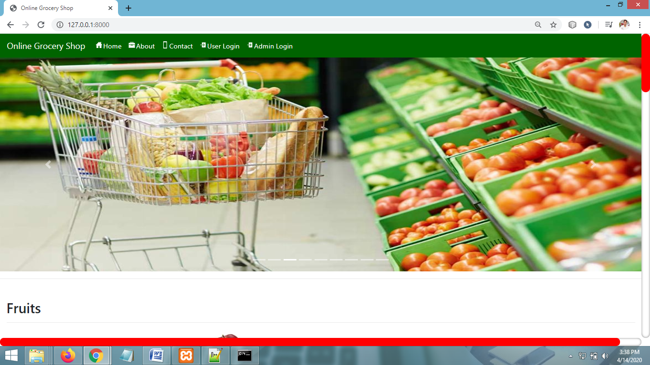

**USER LOGIN PAGE**

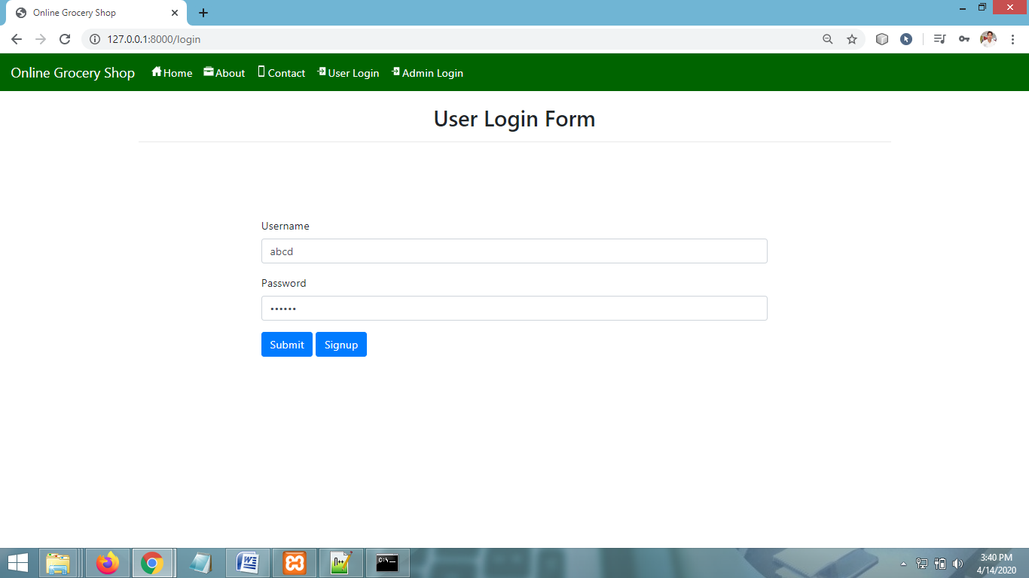

**SIGNUP PAGE**

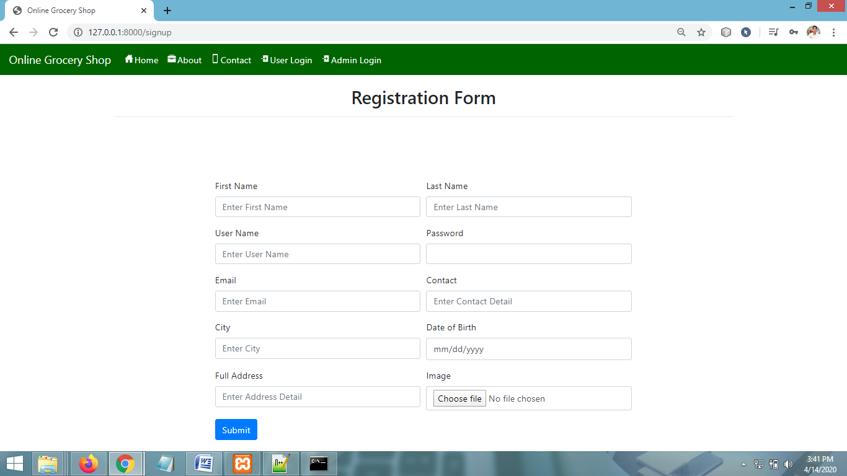

**PRODUCT CATEGORIES PAGE**

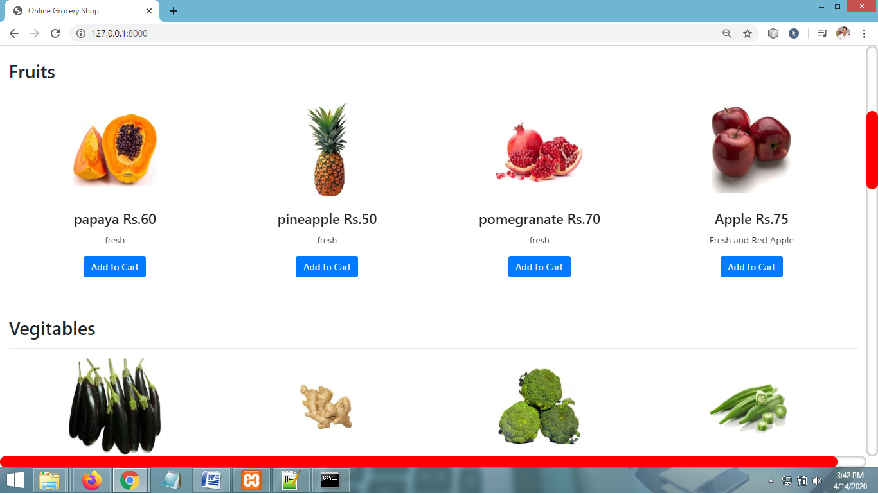

**VIEW CART PAGE**

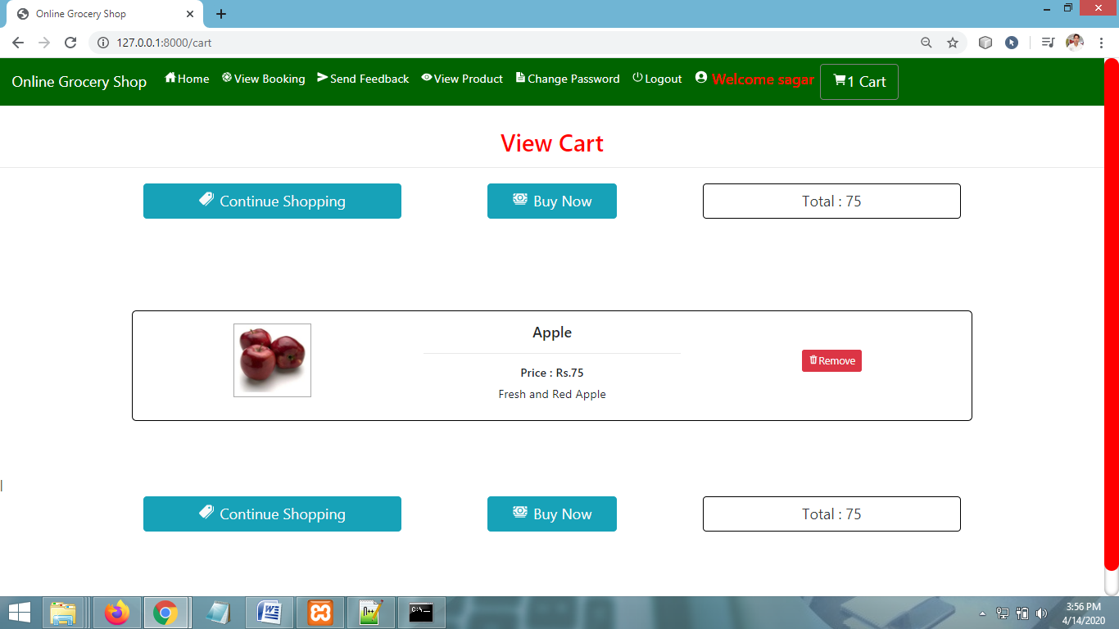

**BOOKING PAGE**

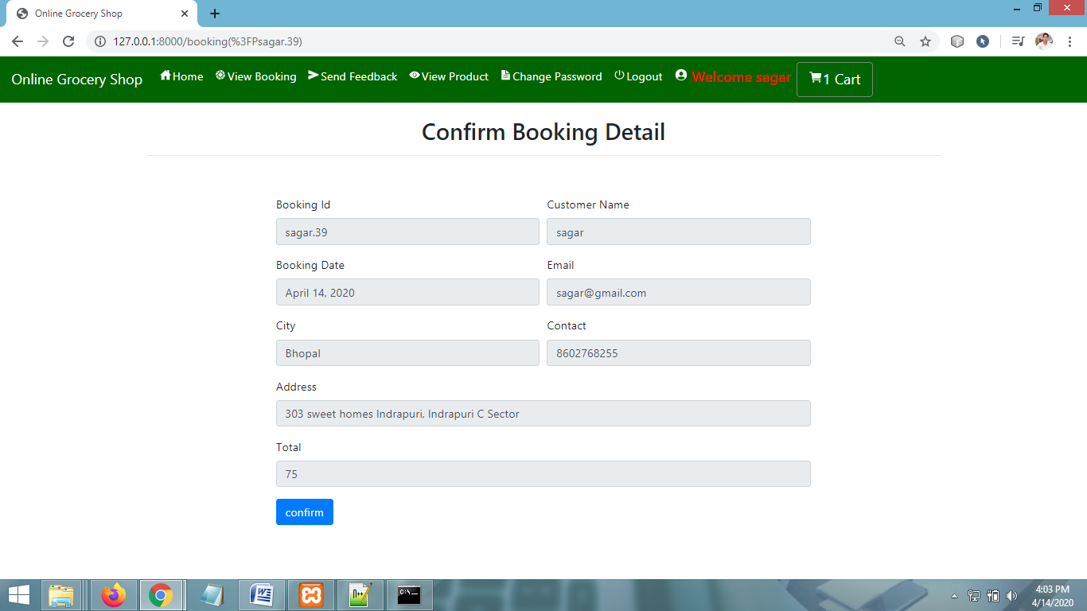

**VIEW PRODUCTS PAGE**

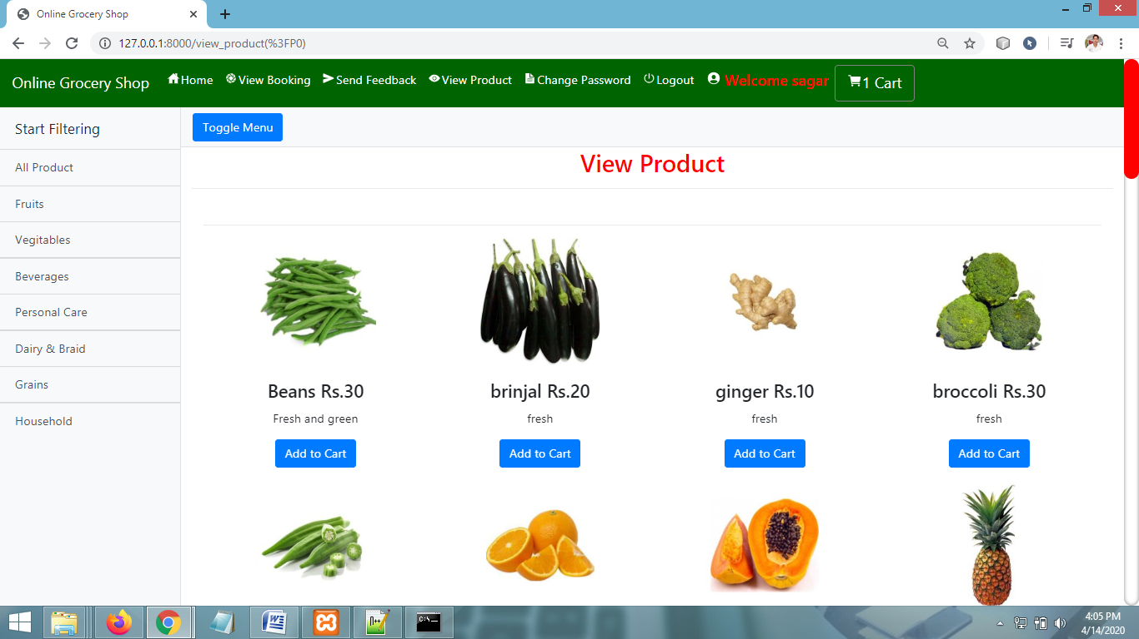

**PAYMENT PAGE**

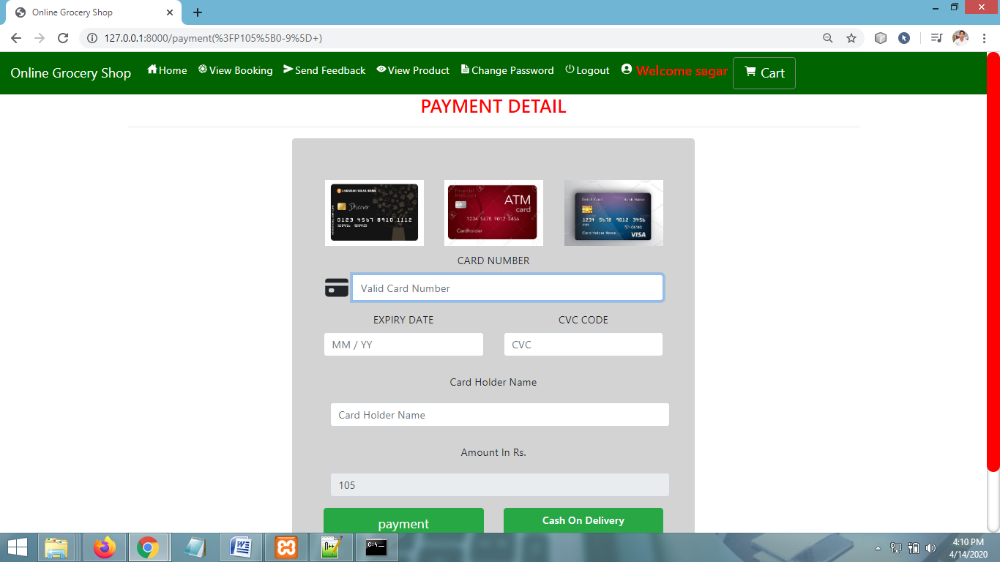

**VIEW BOOKING PAGE (Customer)**

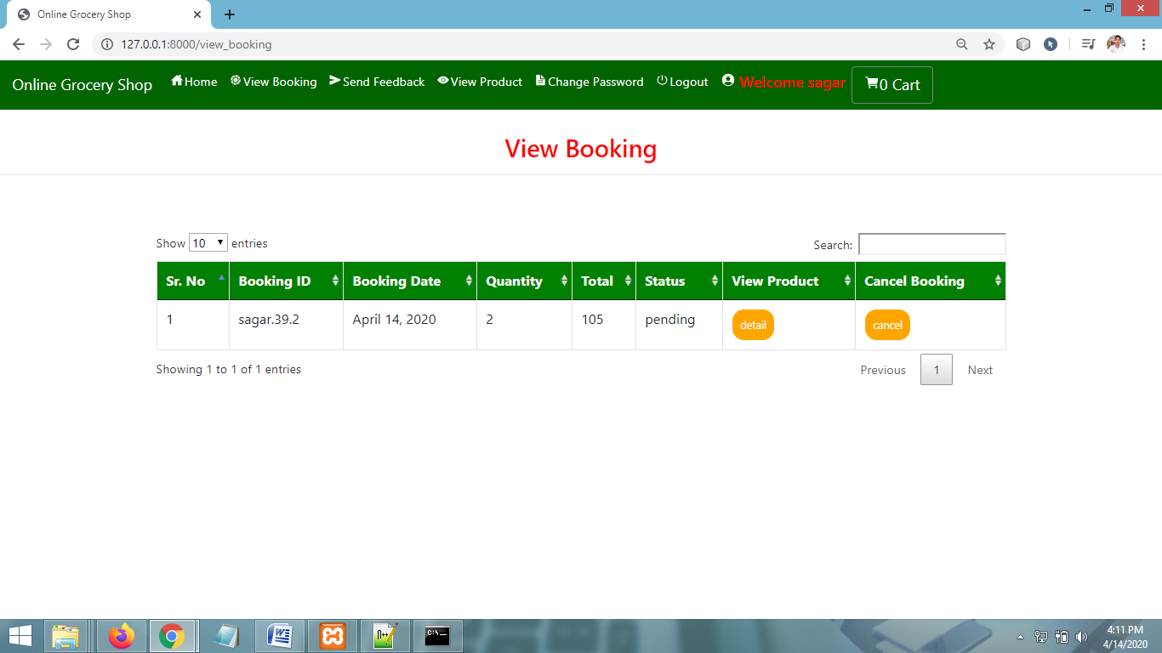

**CHANGE PASSWORD PAGE**

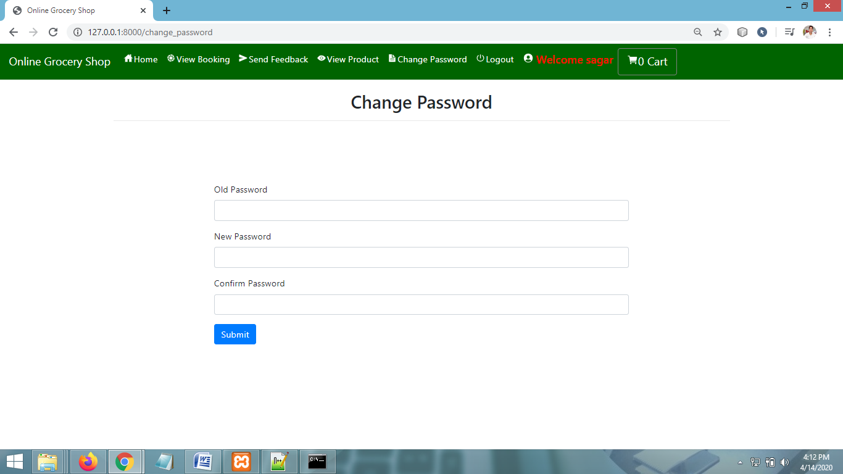

**SEND FEEDBACK PAGE**

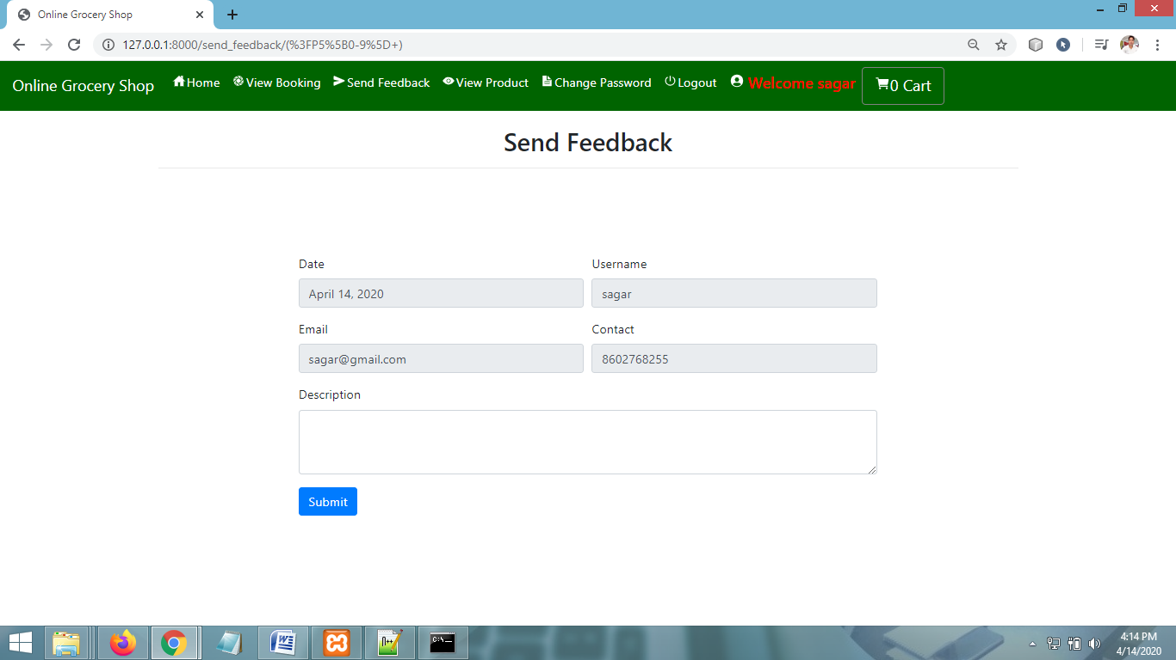

**VIEW PROFILE PAGE**

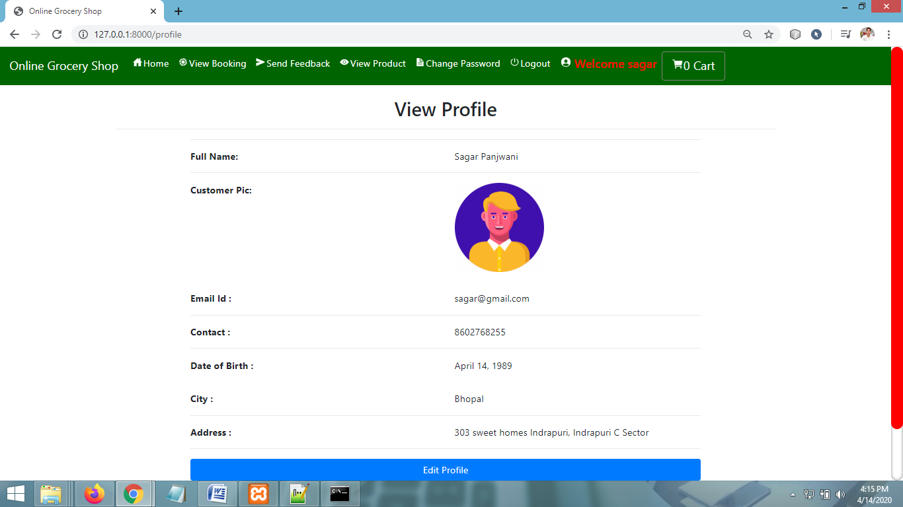

**ADMIN HOME PAGE**

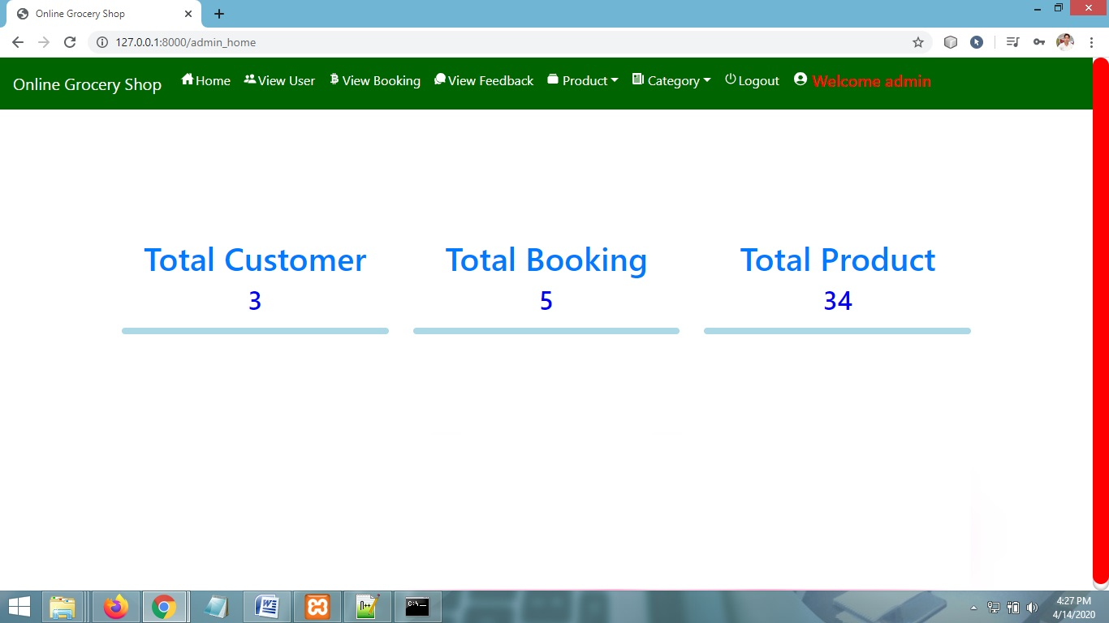

**ADD NEW PRODUCT PAGE**

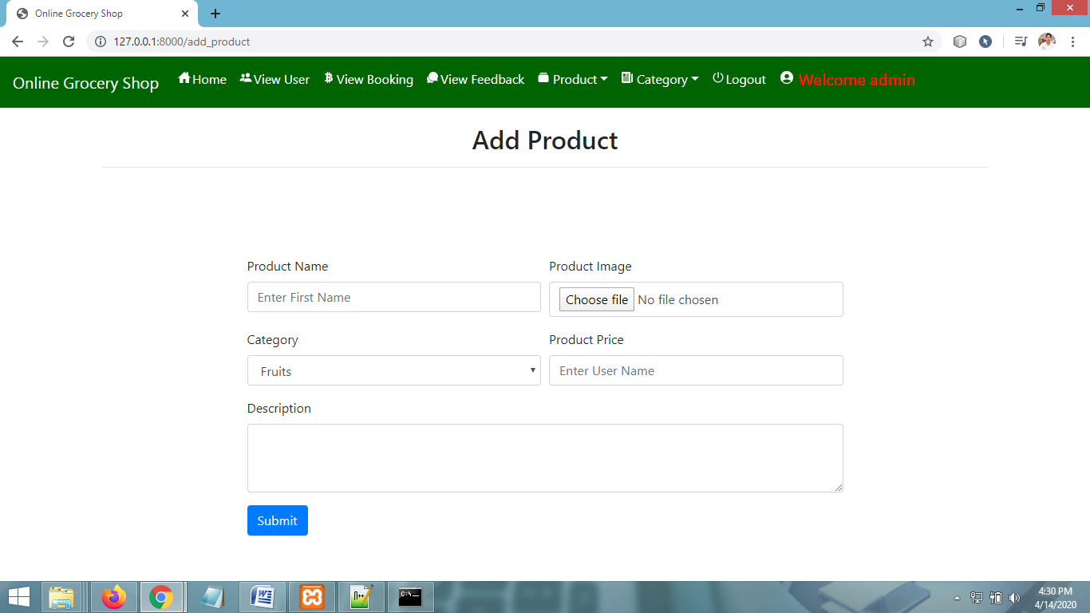

**VIEW PRODUCTS PAGE**

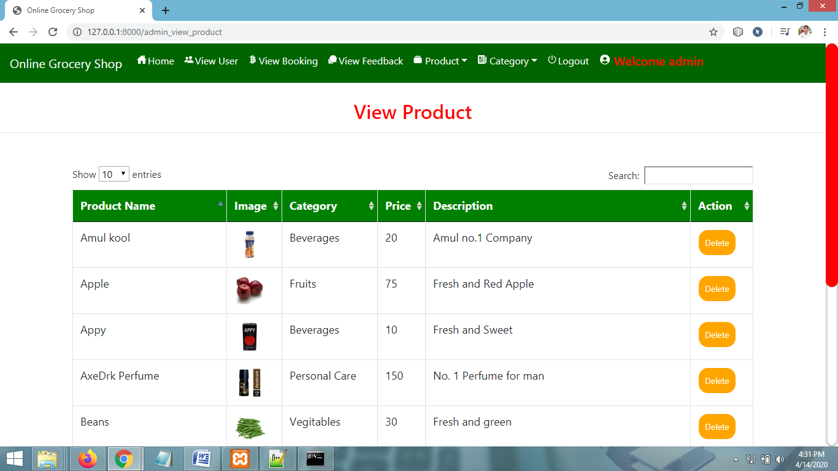

**VIEW CATEGORY PAGE**

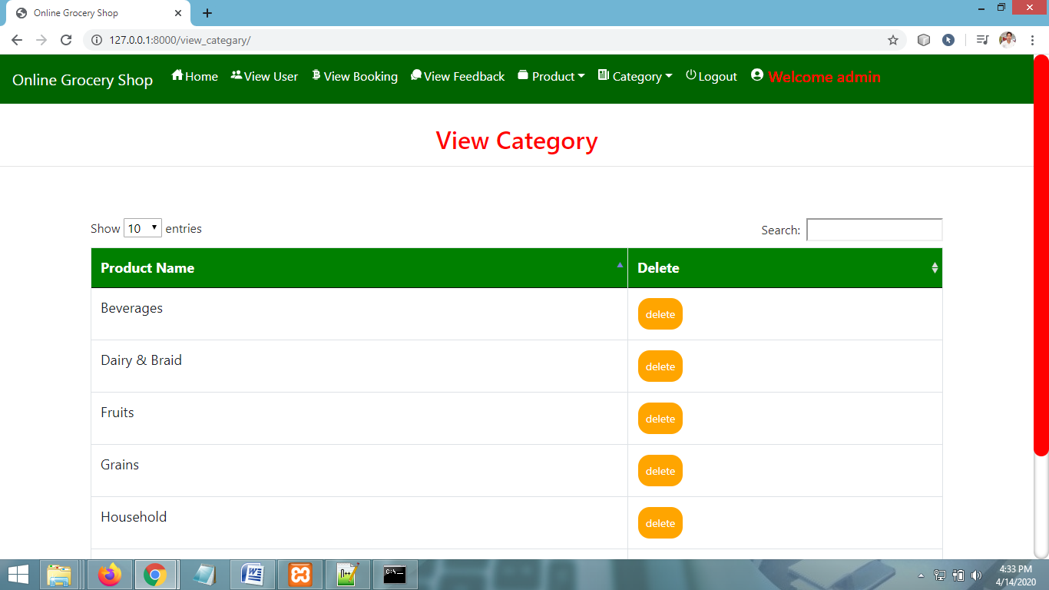

**VIEW BOOKING**

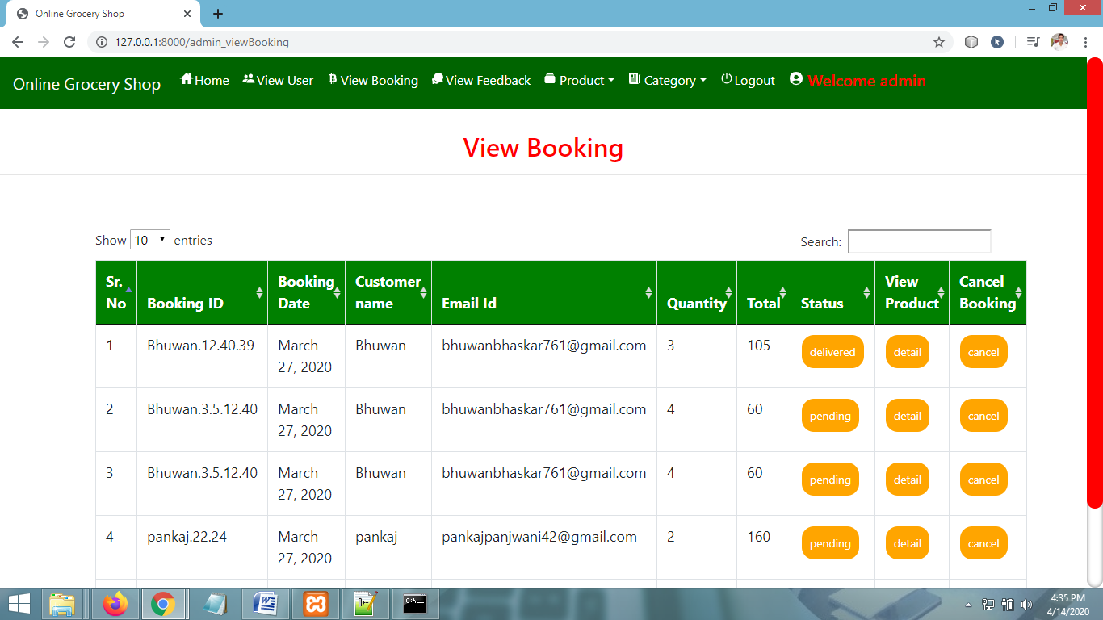

**VIEW USERS PAGE**

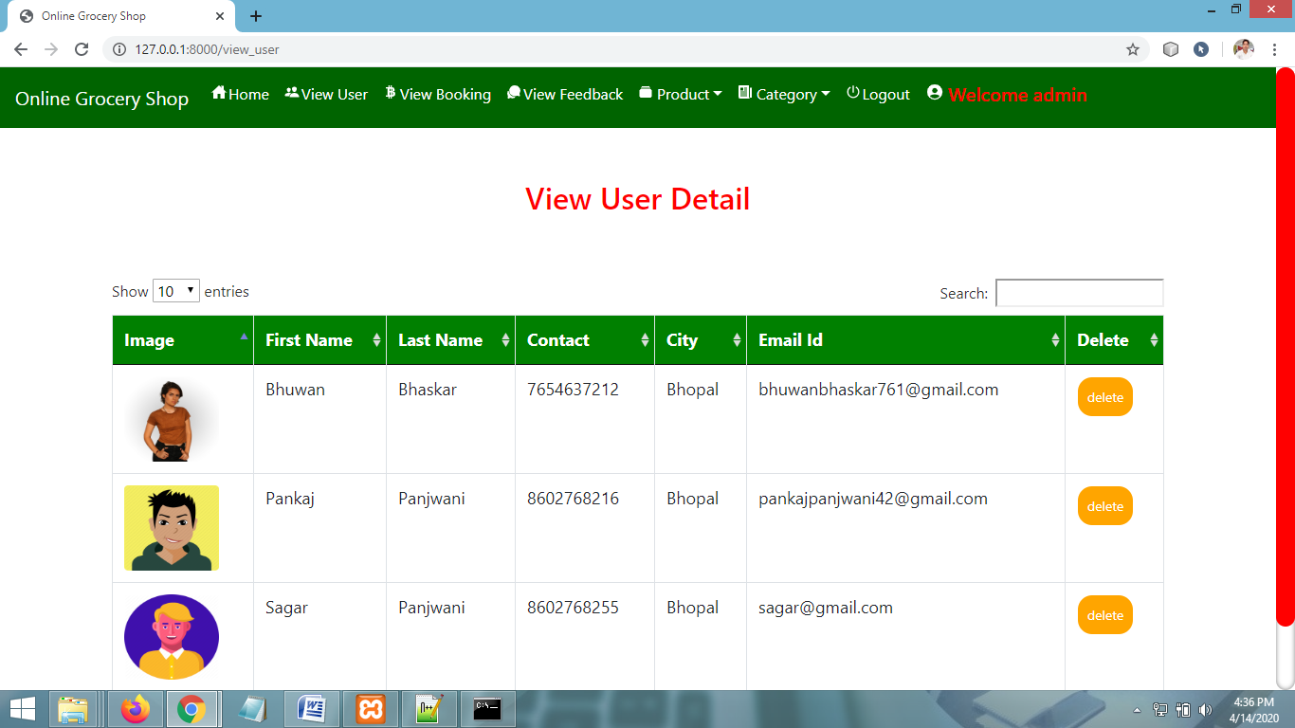

**CHAPTER** # **7**

***Coding***

**USER LOGIN PAGE CODING**

**{% extends 'navigation.html' %}**

**{% block body %}**

**{% load static %}**

**{% ifequal error "yes" %}**

**<script>**

**alert('logged in successfully');**

**window.location=('{% url 'home' %}');**

**</script>**

**{% endifequal %}**

**{% ifequal error "not" %}**

**<script>**

**alert('Username & Password are not Matching');**

**</script>**

**{% endifequal %}**

**<div class="container">**

**<h2 style="margin-top:20px" align="center">User Login Form</h2><hr>**

**<div class="container-fluid" style="width:70%;margin-top:10%">**

**<form method="post" action="">**

**{% csrf_token %}**

**<div class="form-group">**

**<label for="exampleInputEmail1">Username</label>**

**<input type="text" class="form-control" id="exampleInputEmail1" aria-describedby="emailHelp" name="uname" placeholder="Enter Username">**

**</div>**

**<div class="form-group">**

**<label for="exampleInputPassword1">Password</label>**

**<input type="password" class="form-control" id="exampleInputPassword1" placeholder="Password" name="pwd">**

**</div>**

**<button type="submit" class="btn btn-primary">Submit</button>**

**<button class="btn btn-primary"><a href="{% url 'signup' %}" style="color:white">Signup</a></button>**

**</form>**

**</div>**

**</div>**

**{% endblock %}**

**SIGNUP PAGE CODING**

**{% extends 'navigation.html' %}**

**{% block body %}**

**{% load static %}**

**<div class="container">**

**<h2 style="margin-top:20px" align="center">Registration Form</h2><hr>**

**<div class="container-fluid" style="width:70%;margin-top:10%">**

**<form method="post" action="" enctype="multipart/form-data">**

**{% csrf_token %}**

**<div class="form-row">**

**<div class="form-group col-md-6">**

**<label for="inputEmail4">First Name</label>**

**<input type="text" class="form-control" placeholder="Enter First Name" name="fname" id="inputEmail4">**

**</div>**

**<div class="form-group col-md-6">**

**<label for="inputPassword4">Last Name</label>**

**<input type="text" class="form-control" name="lname" placeholder="Enter Last Name" id="inputPassword4">**

**</div>**

**</div>**

**<div class="form-row">**

**<div class="form-group col-md-6">**

**<label for="inputEmail4">User Name</label>**

**<input type="text" class="form-control" name="uname" placeholder="Enter User Name" id="inputEmail4">**

**</div>**

**<div class="form-group col-md-6">**

**<label for="inputPassword4">Password</label>**

**<input type="password" class="form-control" name="pwd" id="inputPassword4">**

**</div>**

**</div>**

**<div class="form-row">**

**<div class="form-group col-md-6">**

**<label for="exampleInputEmail1">Email</label>**

**<input type="email" class="form-control" id="exampleInputEmail1" aria-describedby="emailHelp" name="email" placeholder="Enter Email">**

**</div>**

**<div class="form-group col-md-6">**

**<label for="exampleInputPassword1">Contact</label>**

**<input type="text" class="form-control" id="exampleInputPassword1" placeholder="Enter Contact Detail" name="contact">**

**</div>**

**</div>**

**<div class="form-row">**

**<div class="form-group col-md-6">**

**<label for="exampleInputPassword1">City</label>**

**<input type="text" class="form-control" id="exampleInputPassword1" placeholder="Enter City" name="city">**

**</div>**

**<div class="form-group col-md-6">**

**<label for="exampleInputPassword1">Date of Birth</label>**

**<input type="date" class="form-control" id="exampleInputPassword1" name="date">**

**</div>**

**</div>**

**<div class="form-row">**

**<div class="form-group col-md-6">**

**<label for="exampleInputPassword1">Full Address</label>**

**<input type="text" class="form-control" id="exampleInputPassword1" placeholder="Enter Address Detail" name="add">**

**</div>**

**<div class="form-group col-md-6">**

**<label for="exampleInputPassword1">Image</label>**

**<input type="file" class="form-control" id="exampleInputPassword1" name="img" value="choose file">**

**</div></div>**

**<button type="submit" class="btn btn-primary">Submit</button>**

**</form>**

**</div>**

**</div>**

**{% if error %}**

**<script>**

**alert('Regitered Successfully');**

**window.location = "{% url 'login' %}";**

**</script>**

**{% endif %}**

**{% endblock %}**

**VIEW CART PAGE CODING**

**{% extends 'navigation.html' %}**

**{% block body %}**

**<center><h2 style="color:red;margin-top:2%">View Cart</h2></center><hr>**

**{% if not cart %}**

**<h1 align="center" style="color:blue">{{message}}</h1>**

**{% else %}**

**<center><div class="container" style="border:1px solid white">**

**<div class="row">**

**<div class="col-md-4" style="height:100px;">**

**<center><a href="{% url 'view_product' 0 %}" style="margin-top:1%;width:100%" class="btn btn-lg btn-info text-light text-capitalize"><ion-icon style="margin-right:8px" name="pricetags"></ion-icon>Continue Shopping</a></center>**

**</div>**

**<div class="col-md-4" style="height:100px;">**

**<center><a href="{% url 'booking' book %}" style="margin-top:1%;width:50%" class="btn btn-lg btn-info text-light text-capitalize"><ion-icon style="margin-right:8px" name="cash"></ion-icon>Buy Now</a></center>**

**</div>**

**<div class="col-md-4" style="height:100px;">**

**<center><a style="margin-top:1%;width:100%;border:1px solid black" class="btn btn-default btn-lg text-dark text-capitalize">Total : {{total}}</a></center>**

**</div>**

**</div>**

**</div>**

**</center>**

**{% for i in cart %}**

**<center>**

**<style>**

**.container{**

**border:1px solid black;**

**border-radius:6px;**

**margin-bottom:5%;**

**}.container1 ,.contain{**

**border:1px solid black;**

**border-radius:6px;**

**width:70%;**

**border:1px solid black;**

**}**

**</style>**

**<div class="container" style="margin-top:2%;height:150px;width:80%">**

**<div class="row" style="height:90%">**

**<div class="col-md-4" style="height:120px">**

**<img src="{{i.product.image.url}}" style="width:30%;height:100px;border:1px solid darkgray;margin-top:5%">**

**</div>**

**<div class="col-md-4" style="height:100px">**

**<h5 style="margin-top:5%">{{i.product.name}}</h5><hr>**

**<h6>Price : Rs.{{i.product.price}}</h6>**

**<p>{{i.product.desc}}</p>**

**</div>**

**<div class="col-md-4" style="height:100px;">**

**<center><a href="{% url 'remove_cart' i.id %}" style="margin-top:15%" class="btn btn-sm btn-danger text-light text-capitalize"><ion-icon name="trash"></ion-icon>Remove</a></center>**

**</div>**

**</div>**

**</div>**

**</center>**

**{% endfor %}**

**|<div class="container" style="border:1px solid white">**

**<div class="row">**

**<div class="col-md-4" style="height:100px;">**

**<center><a href="{% url 'view_product' 0 %}" style="margin-top:1%;width:100%" class="btn btn-lg btn-info text-light text-capitalize"><ion-icon style="margin-right:8px" name="pricetags"></ion-icon>Continue Shopping</a></center>**

**</div>**

**<div class="col-md-4" style="height:100px;">**

**<center><a href="{% url 'booking' book %}" style="margin-top:1%;width:50%" class="btn btn-lg btn-info text-light text-capitalize"><ion-icon style="margin-right:8px" name="cash"></ion-icon>Buy Now</a></center>**

**</div>**

**<div class="col-md-4" style="height:100px;">**

**<center><a style="margin-top:1%;width:100%;border:1px solid black" class="btn btn-default btn-lg text-dark text-capitalize">Total : {{total}}</a></center>**

**</div>**

**</div>**

**{% endif %}**

**</div>**

**{% endblock %}**

**ADMIN HOME PAGE CODING**

**{% extends 'navigation.html' %}**

**{% load static %}**

**{% block body %}**

**<style>**

**.glow {**

**font-size: 80px;**

**color: #fff;**

**text-align: center;**

**-webkit-animation: glow 1s ease-in-out infinite alternate;**

**-moz-animation: glow 1s ease-in-out infinite alternate;**

**animation: glow 1s ease-in-out infinite alternate;**

**}**

**@-webkit-keyframes glow {**

**from {**

**text-shadow: 0 0 10px #fff, 0 0 20px #fff, 0 0 30px #e60073, 0 0 40px #e60073, 0 0 50px #e60073, 0 0 60px #e60073, 0 0 70px #e60073;**

**}**

**to {**

**text-shadow: 0 0 20px #fff, 0 0 30px #ff4da6, 0 0 40px #ff4da6, 0 0 50px #ff4da6, 0 0 60px #ff4da6, 0 0 70px #ff4da6, 0 0 80px #ff4da6;**

**}**

**}**

**/* Rounded border */**

**hr.rounded {**

**border-top: 8px solid lightblue;**

**border-radius: 5px;**

**}**

**</style>**

**</style>**

**<link rel="stylesheet" href="https://use.fontawesome.com/releases/v5.7.0/css/all.css" integrity="sha384-lZN37f5QGtY3VHgisS14W3ExzMWZxybE1SJSEsQp9S+oqd12jhcu+A56Ebc1zFSJ" crossorigin="anonymous">**

**<br>**

**<center>**

**<div class="container" style="margin-top:10%;height:150px;width:80%">**

**<div class="row" style="height:90%">**

**<div class="col-md-4">**

**<a href="{% url 'view_user' %}"><h1>Total Customer</h1>**

**<h2 style="color:blue">{{total_customer}}</h2>**

**<hr class="rounded"></a>**

**</div>**

**<div class="col-md-4">**

**<a href="{% url 'admin_viewBooking' %}"><h1>Total Booking</h1>**

**<h2 style="color:blue">{{total_book}}</h2>**

**<hr class="rounded"></a>**

**</div>**

**<div class="col-md-4">**

**<a href="{% url 'admin_view_product' %}">**

**<h1>Total Product</h1>**

**<h2 style="color:blue">{{total_pro}}</h2>**

**<hr class="rounded"></a>**

**</div>**

**</div>**

**</div>**

**</center>**

**<footer class="site-footer">**

**<div class="container">**

**<div class="row pt-5 mt-5 text-center">**

**<div class="col-md-12">**

**<p style = "font-size : 30pt ; color : #FF0000 ; font-weight : bold">**

**Copyright &copy;<script>document.write(new Date().getFullYear());</script> All Rights Reserved <span style = "color : brown">|</span> <span style = "color : #006400">This website is made with <i class="fas fa-heart icon-heart text-warning" aria-hidden="true"></i> by </span><a class= "glow" href="#" target="_blank" >Pankaj Panjwani</a>**

**</p>**

**</div>**

**</div>**

**</div>**

**</footer>**

**{% endblock %}**

**VIEW BOOKING PAGE CODING**

**{% extends 'navigation.html' %}**

**{% block body %}**

**<center><h2 style="color:red;margin-top:2%">View Booking Detail</h2></center><hr>**

**{% for i in product %}**

**{% if i.id in book %}**

**<center>**

**<style>**

**.container{**

**border:1px solid black;**

**border-radius:6px;**

**margin-bottom:5%;**

**}.container1 ,.contain{**

**border:1px solid black;**

**border-radius:6px;**

**width:70%;**

**border:1px solid black;**

**}**

**</style>**

**<div class="container" style="margin-top:2%;height:150px;width:80%">**

**<div class="row" style="height:90%">**

**<div class="col-md-4" style="height:120px">**

**<img src="{{i.image.url}}" style="width:30%;height:100px;border:1px solid darkgray;margin-top:5%">**

**</div>**

**<div class="col-md-4" style="height:100px">**

**<h5 style="margin-top:5%">{{i.name}}</h5><hr>**

**<h6>Price : Rs.{{i.price}}</h6>**

**<p>{{i.desc}}</p>**

**</div>**

**<div class="col-md-4" style="height:100px;">**

**<h4 style="margin-top:15%;color:blue">Booked Successfully</h4>**

**</div>**

**</div>**

**</div> </center>**

**{% endif %}**

**{% endfor %}**

**<div class="container" style="border:1px solid white">**

**<div class="row">**

**<div class="col-md-6" style="height:100px;">**

**<center><a style="margin-top:1%;width:100%;border:1px solid black" class="btn btn-default btn-lg text-dark text-capitalize">Total : {{total.total}}</a></center>**

**</div></div>**

**<center><h2 style="color:red;margin-top:2%">Customer Detail</h2></center><hr>**

**<div class="row">**

**<div class="col-md-6" style="height:100px;"><hr>**

**<h4>Name : {{profile.user.first_name}} {{profile.user.last_name}}</h4><hr>**

**<h4>Email : {{profile.user.email}}</h4><hr>**

**<h4>Address : {{profile.address}}</h4><hr>**

**<h4>Contact : {{profile.contact}}</h4><hr>**

**</div>**

**<div class="col-md-6" style="height:100px;"><hr>**

**<h4> <img src="{{profile.image.url}}" style="width:150px;height:140px"></h4>**

**</div>**

**</div>**

**</div>**

**{% endblock %}**

**VIEW PRODUCTS PAGE CODING**

**{% extends 'navigation.html' %}**

**{% block body %}**

**<center><h2 style="color:red;margin-top:2%">View Product</h2></center><hr>**

**<div class="container" style="margin-top:4%">**

**<table class="table table-bordered" id="myTable">**

**<thead>**

**<tr>**

**<th>Product Name</th>**

**<th>Image</th>**

**<th> Category</th>**

**<th>Price</th>**

**<th> Description</th>**

**<th>Action</th>**

**</tr>**

**</thead>**

**<tbody>**

**{% for i in pro %}**

**<tr>**

**<td>{{i.name}}</td>**

**<td><img src="{{i.image.url}}" style="width:50px;height:50px"></td>**

**<td>{{i.category.name}}</td>**

**<td>{{i.price}}</td>**

**<td>{{i.desc}}</td>**

**<td><a href="{% url 'delete_product' i.id %}" onclick="return confirm('Are you sure?')"><button class="button button1">Delete</button></a></td>**

**</tr>**

**{% endfor %}**

**</tbody>**

**{{count}}**

**</table>**

**</div>**

**<script>**

**{% for i in message %}**

**alert("{{i}}")**

**{% endfor %}**

**</script>**

**{% endblock %}**

**ADD PRODUCT PAGE CODING**

**{% extends 'navigation.html' %}**

**{% block body %}**

**{% load static %}**

**<div class="container">**

**<h2 style="margin-top:20px" align="center">Add Product</h2><hr>**

**<div class="container-fluid" style="width:70%;margin-top:10%">**

**<form method="post" action="" enctype="multipart/form-data">**

**{% csrf_token %}**

**<div class="form-row">**

**<div class="form-group col-md-6">**

**<label for="inputEmail4">Product Name</label>**

**<input type="text" class="form-control" placeholder="Enter First Name" name="pname" id="inputEmail4">**

**</div>**

**<div class="form-group col-md-6">**

**<label for="exampleInputPassword1">Product Image</label>**

**<input type="file" class="form-control" id="exampleInputPassword1" name="img" value="choose file">**

**</div></div>**

**<div class="form-row">**

**<div class="form-group col-md-6">**

**<label for="inputState">Category</label>**

**<select id="inputState" class="form-control" name="cat">**

**{% for i in cat %}**

**<option value="{{i.name}}">{{i.name}}</option>**

**{% endfor %}**

**</select>**

**</div>**

**<div class="form-group col-md-6">**

**<label for="inputEmail4">Product Price</label>**

**<input type="number" class="form-control" name="price" placeholder="Enter User Name" id="inputEmail4">**

**</div></div>**

**<div class="form-group">**

**<label for="exampleFormControlTextarea1">Description</label>**

**<textarea class="form-control" id="exampleFormControlTextarea1" name="desc" rows="3"></textarea>**

**</div>**

**<button type="submit" class="btn btn-primary">Submit</button>**

**</form>**

**</div>**

**</div>**

**{% if error %}**

**<script>**

**alert('1 Product Added Successfully');**

**</script>**

**{% endif %}**

**{% endblock %}**

**ADD CATEGORY PAGE CODING**

**{% extends 'navigation.html' %}**

**{% block body %}**

**{% load static %}**

**{% if error %}**

**<script>**

**alert('One New Category Added Successfully');**

**</script>**

**{% endif %}**

**<div class="container">**

**<h2 style="margin-top:20px" align="center">Add Category</h2><hr>**

**<div class="container-fluid" style="width:70%;margin-top:10%">**

**<form method="post" action="">**

**{% csrf_token %}**

**<div class="form-group">**

**<label for="exampleInputEmail1">Category Name</label>**

**<input type="text" class="form-control" id="exampleInputEmail1" aria-describedby="emailHelp" name="cat" placeholder="Enter Category">**

**</div>**

**<button type="submit" class="btn btn-primary">Submit</button>**

**</form>**

**</div>**

**</div>**

**{% endblock %}**

**USER EDIT PROFILE PAGE CODING**

**{% extends 'navigation.html' %}**

**{% block body %}**

**{% load static %}**

**<div class="container">**

**<h2 style="margin-top:20px" align="center">Edit Profile</h2><hr>**

**<div class="container-fluid" style="width:70%;margin-top:10%">**

**<form method="post" action="" enctype="multipart/form-data">**

**{% csrf_token %}**

**<div class="form-row">**

**<div class="form-group col-md-6">**

**<label for="inputEmail4">First Name</label>**

**<input type="text" class="form-control" value="{{pro.user.first_name}}" name="fname" id="inputEmail4">**

**</div>**

**<div class="form-group col-md-6">**

**<label for="inputPassword4">Last Name</label>**

**<input type="text" class="form-control" name="lname" value="{{pro.user.last_name}}" id="inputPassword4">**

**</div>**

**</div>**

**<div class="form-row">**

**<div class="form-group col-md-12">**

**<label for="inputEmail4">User Name</label>**

**<input type="text" class="form-control" name="uname" value="{{pro.user.username}}" id="inputEmail4" readonly>**

**</div>**

**</div>**

**<div class="form-row">**

**<div class="form-group col-md-6">**

**<label for="exampleInputEmail1">Email</label>**

**<input type="email" class="form-control" id="exampleInputEmail1" aria-describedby="emailHelp" name="email" value="{{pro.user.email}}">**

**</div>**

**<div class="form-group col-md-6">**

**<label for="exampleInputPassword1">Contact</label>**

**<input type="text" class="form-control" id="exampleInputPassword1" value="{{pro.contact}}" name="contact">**

**</div>**

**</div>**

**<div class="form-row">**

**<div class="form-group col-md-12">**

**<label for="exampleInputPassword1">City</label>**

**<input type="text" class="form-control" id="exampleInputPassword1" value="{{pro.city}}" name="city">**

**</div>**

**</div>**

**<div class="form-row">**

**<div class="form-group col-md-6">**

**<label for="exampleInputPassword1">Date of Birth</label>**

**<input type="date" class="form-control" id="exampleInputPassword1" name="date">**

**</div>**

**<div class="form-group col-md-6">**

**<label for="exampleInputPassword1">Date of Birth</label>**

**<input type="text" class="form-control" id="exampleInputPassword1" value="{{pro.dob}}" readonly>**

**</div>**

**</div>**

**<div class="form-row">**

**<div class="form-group col-md-12">**

**<label for="exampleInputPassword1">Full Address</label>**

**<input type="text" class="form-control" id="exampleInputPassword1" value="{{pro.address}}" name="add">**

**</div>**

**</div>**

**<div class="form-row">**

**<div class="form-group col-md-6">**

**<label for="exampleInputPassword1">Image</label>**

**<input type="file" class="form-control" id="exampleInputPassword1" name="img" value="choose file">**

**</div>**

**<div class="form-group col-md-6">**

**<img src="{{pro.image.url}}" style="width:150px;height:150px">**

**</div>**

**</div>**

**<button type="submit" class="btn btn-primary" style="margin-bottom:5%">update</button>**

**</form>**

**</div>**

**</div>**

**{% if error %}**

**<script>**

**alert('Update Successfully');**

**window.location = "{% url 'profile' %}";**

**</script>**

**{% endif %}**

**{% endblock %}**

**CHAPTER** # **8**

**Advantages & Limitations**

**Advantages of “Online Grocery Shop System”:**

“Online Grocery Shop System” provides various features, which complement the information system and increase the productivity of the system. These features make the system easily usable and convenient. Some of the important features included are listed as follows:

* Intelligent User Forms Design
  + - Data access and manipulation through same forms
    - Access to most required information
* Data Security
* Restrictive data access, as per login assigned only.
* Organized and structured storage of facts.

.

* Strategic Planning made easy.
* No decay of old Records.
* Exact financial position of the Business.

**Limitations of “Online Grocery Shop System”:**

Besides the above achievements and the successful completion of the project, we still feel the project has some limitations, listed as below:

* 1. It is not a large scale system.
  2. Only limited information provided by this system.
  3. Since it is an online project, customers need internet connection to buy products.
  4. People who are not familiar with computers can’t use this software.

**CHAPTER** # **8**

**Future Scope**

**FUTURE SCOPE**

Thisweb application involves almost all the features of the online shopping. The future implementation will be online help for the customers and chatting with website administrator.

**CONCLUSION**

The project entitled “Online Grocery Shopping” is developed using HTML, CSS and Bootstrap as front end and Python Django and Sqlite database in back end to computerize the process of online buying of grocery products. This project covers only the basic features required.

**Bibliography**

**BIBLIOGRAPHY**

* Wikipedia
* <https://www.geeksforgeeks.org/python-django/>
* <https://www.javatpoint.com>
* <https://www.python.org/>
* <https://www.tutorialspoint/>
* **REFERENCE BOOKS**

### Two scoops of Django for 1.11 by Daniel Greenfeld’s and Audrey Greenfield

### Lightweight Django by Elman and Mark Lavin